Argo CD

TASK 1 — Setup ArgoCD on EKS
STEP 1 — Create Namespace
kubectl create namespace argocd
Explanation
Creates a dedicated namespace for ArgoCD resources to keep them isolated.
Validation
kubectl get ns
You should see:
argocd Active
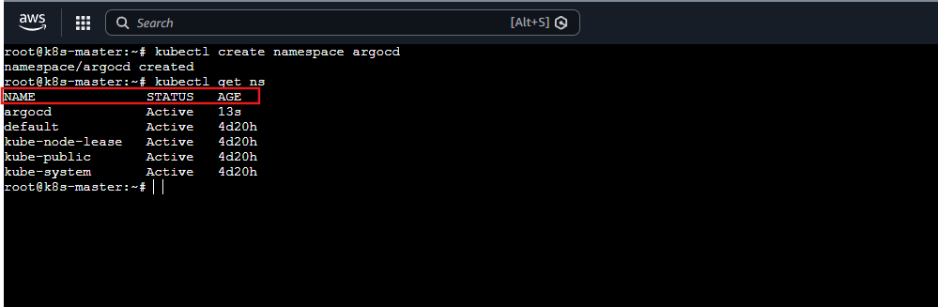
STEP 2 — Install ArgoCD
kubectl apply -n argocd \
-f https://raw.githubusercontent.com/argoproj/argo-cd/stable/manifests/install.yaml
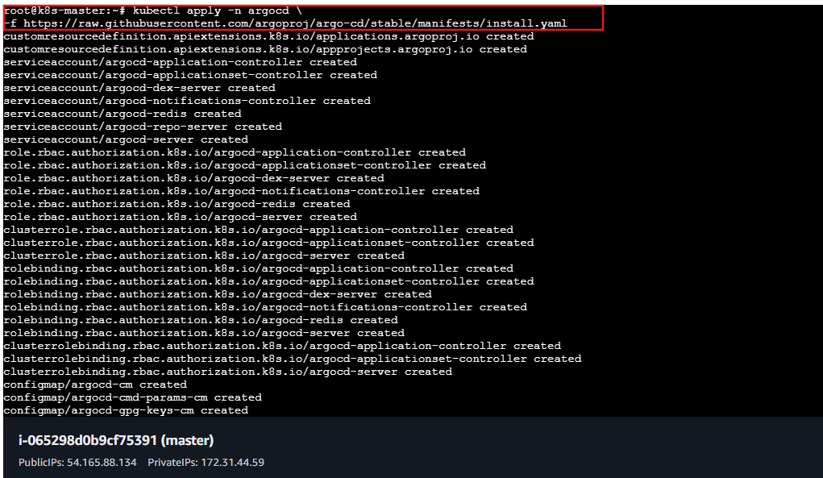
Explanation
Installs:
- ArgoCD API server
- Controller
- Repo server
- Redis
- UI components
Validation
kubectl get pods -n argocd
All pods should be:
STATUS: Running
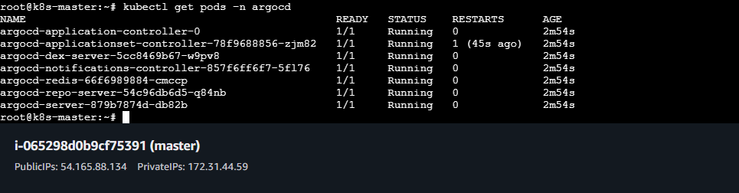
STEP 3 — Expose ArgoCD UI (EKS)
kubectl patch svc argocd-server -n argocd \
-p '{"spec": {"type": "NodePort"}}'
Explanation
Changes service type from ClusterIP → LoadBalancer so AWS provisions an external ELB.
Validation
kubectl get svc argocd-server -n argocd
Access:
https://<master-IP>: 30241
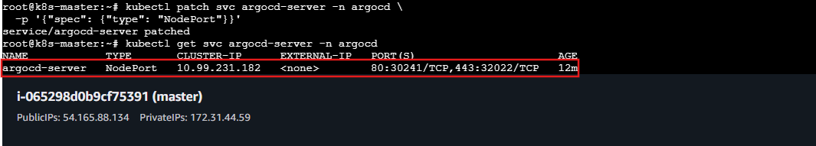
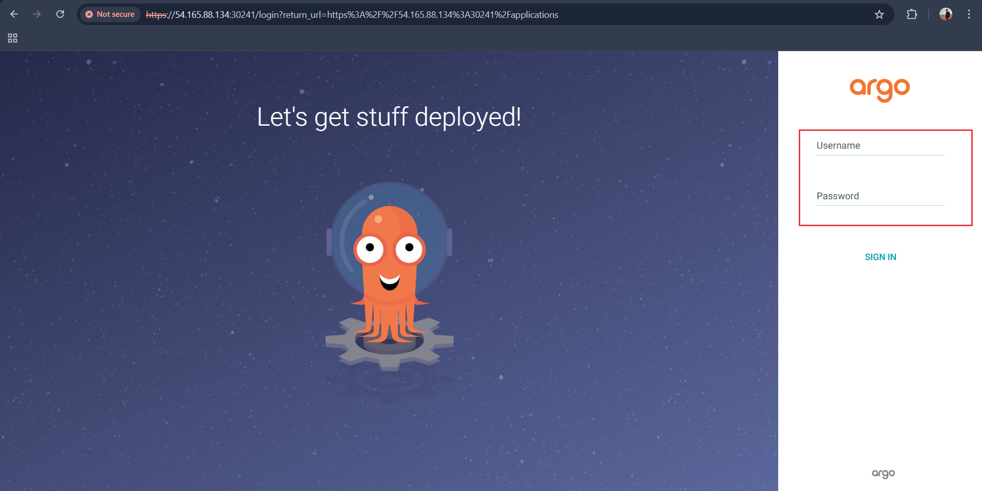
STEP 4 — Get Admin Password
kubectl get secret argocd-initial-admin-secret -n argocd \
-o jsonpath="{.data.password}" | base64 -d
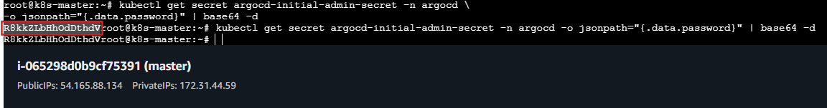
Explanation
Retrieves the initial admin password stored as a Kubernetes secret.
Username: admin password: R8kkZLbHhOdDthdV
Validation
Login to ArgoCD UI successfully.

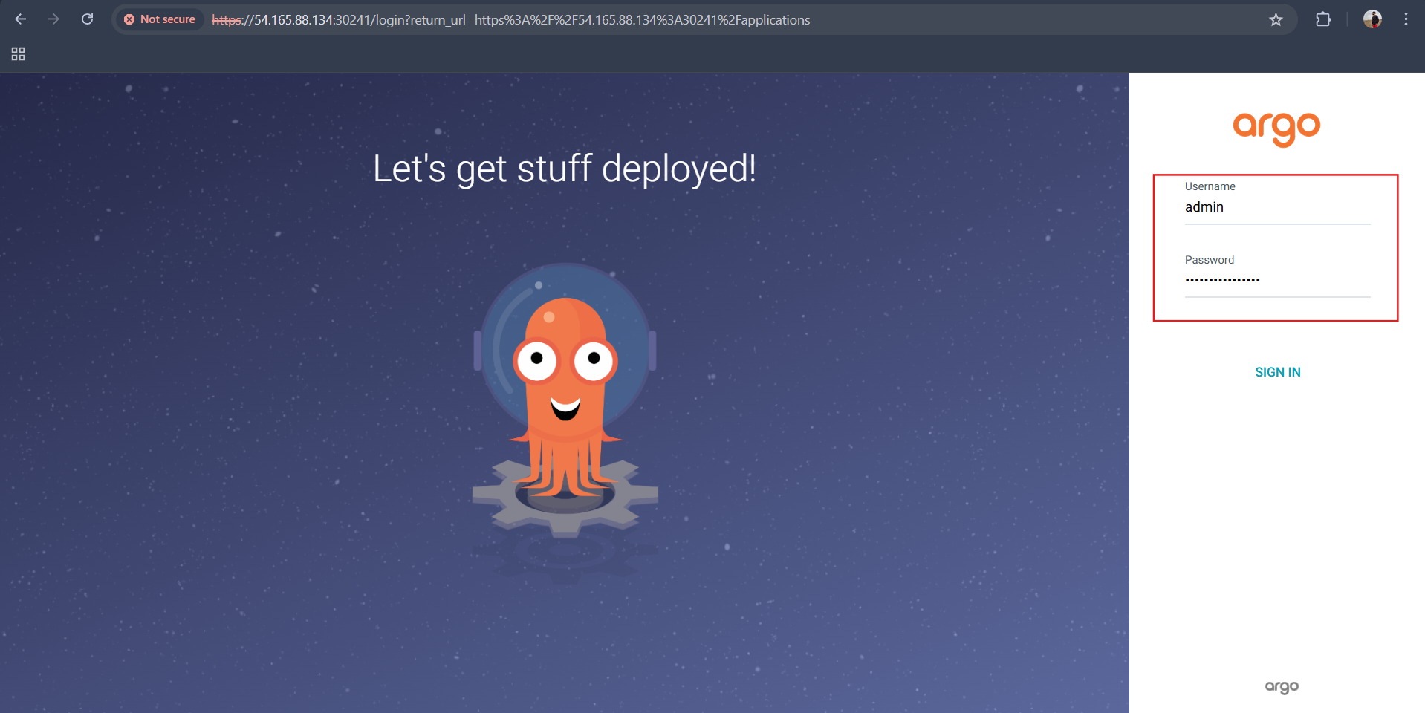
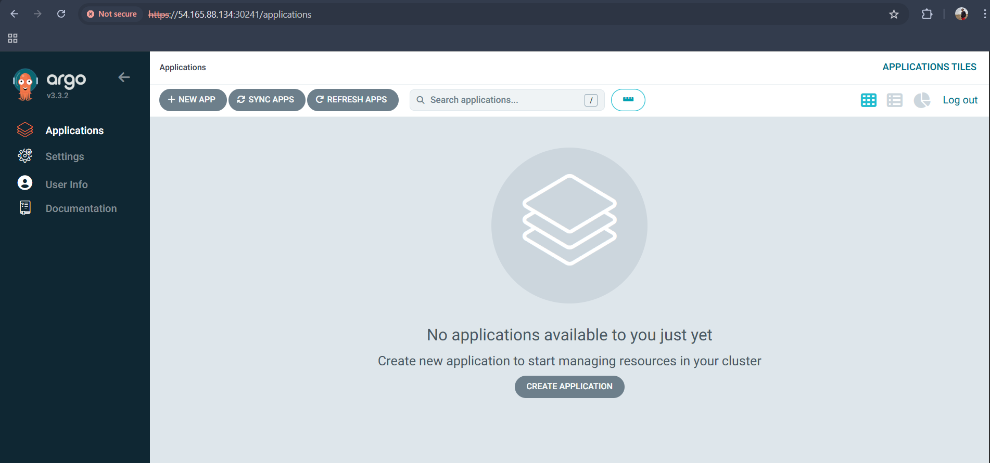

TASK 2 — CI Setup (SonarQube + Nexus + Jenkins)

STEP 2.1 — Install SonarQube
docker run -d --name sonarqube -p 9000:9000 sonarqube:lts
docker ps
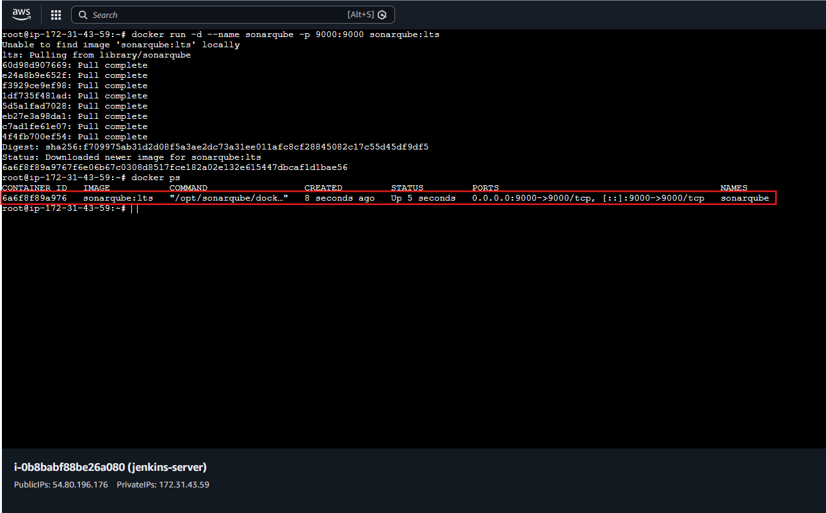
Explanation
Runs SonarQube container for code quality scanning.
Access:
http://JENKINS_IP:9000
Default login:
admin / admin
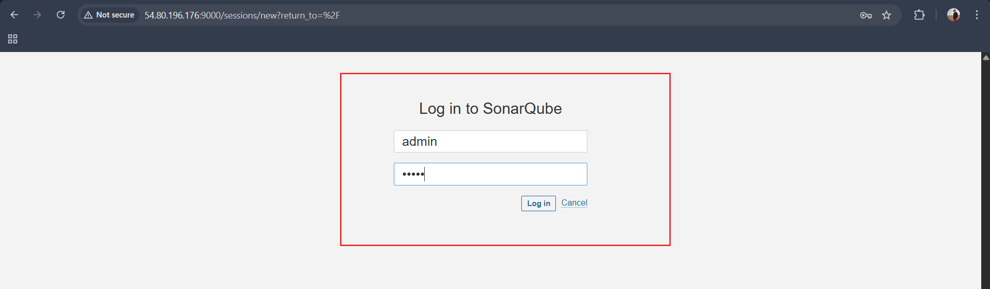
Username: admin
Password: sonarqube
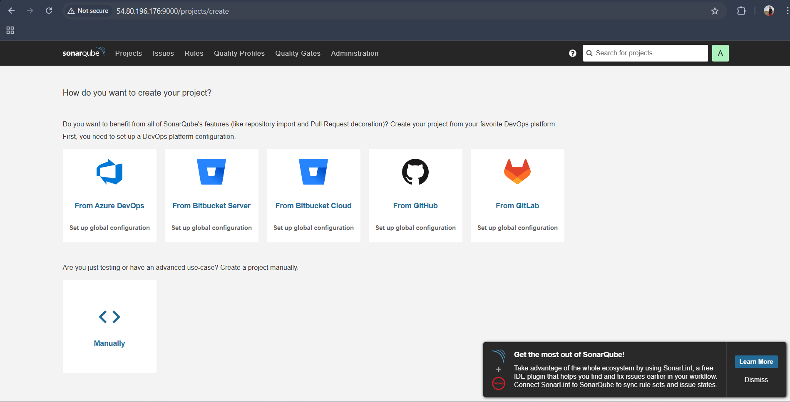
Create:
- security
- Generate Token: sqa_c88a73c700106549fcc444e676d01325cc4da922
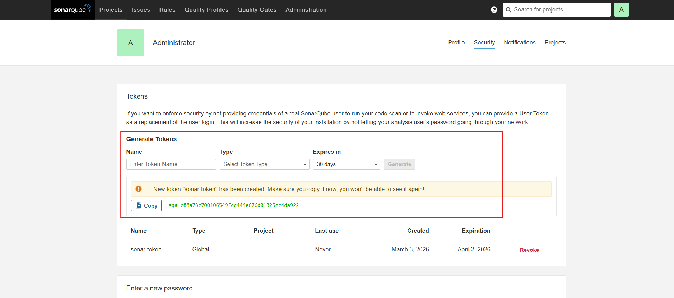
Configure in Jenkins
Manage Jenkins → System → SonarQube Servers
Add:
- Name: SonarServer
- URL: http://JENKINS_IP:9000
- Token
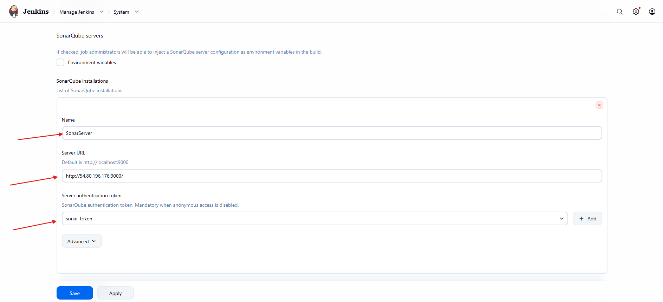
Install plugin:
SonarQube Scanner Plugin
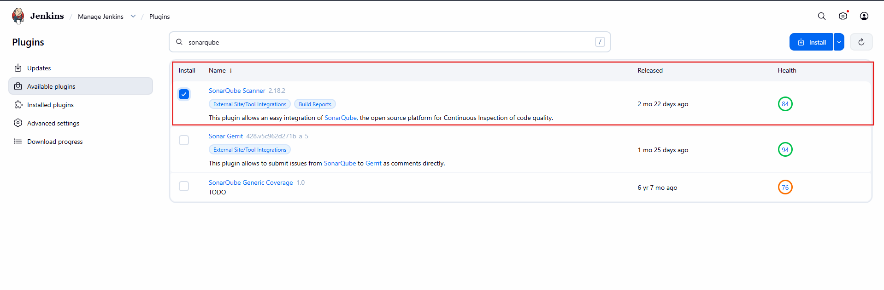
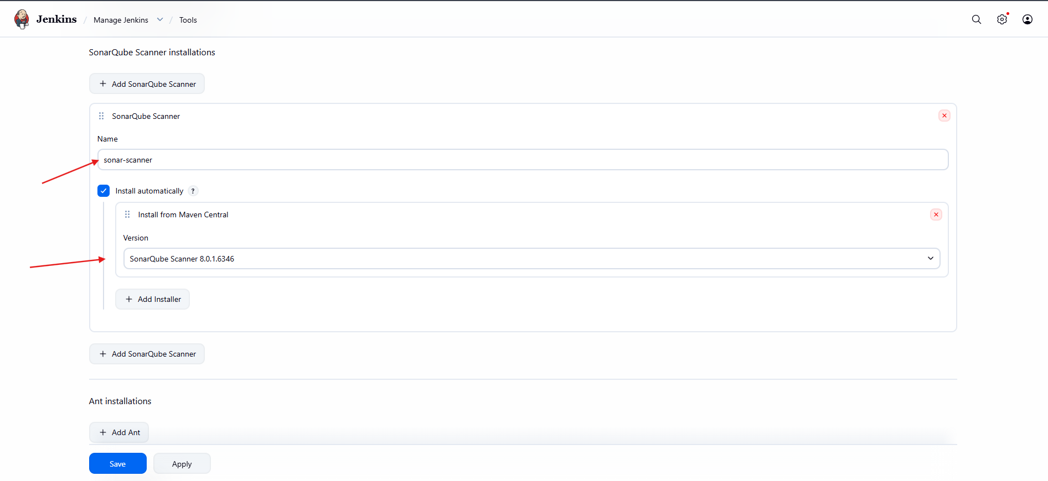
Now Do This (Very Important)
Go to SonarQube:
Administration → Configuration → Webhooks
Make sure you see something like:
Name: jenkins
URL: http://<jenkins-ip>:8080/sonarqube-webhook/
If not added yet → Add it now.
⚠ Must end with /sonarqube-webhook/

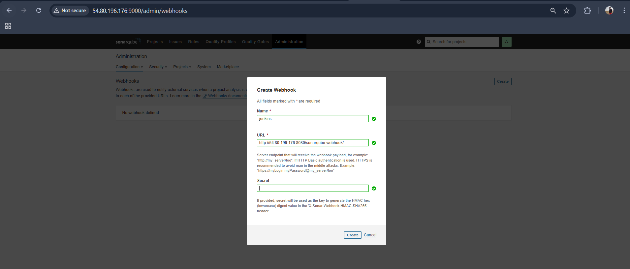
Validation
Run:
docker ps
Sonar container should be running.
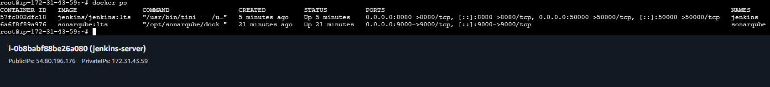
STEP 2.2 — Install Nexus
docker run -d --name nexus -p 8081:8081 sonatype/nexus3
docker ps
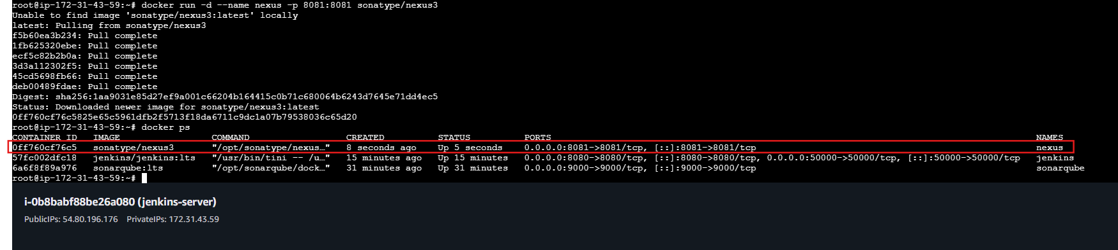
Access:
http://JENKINS_IP:8081
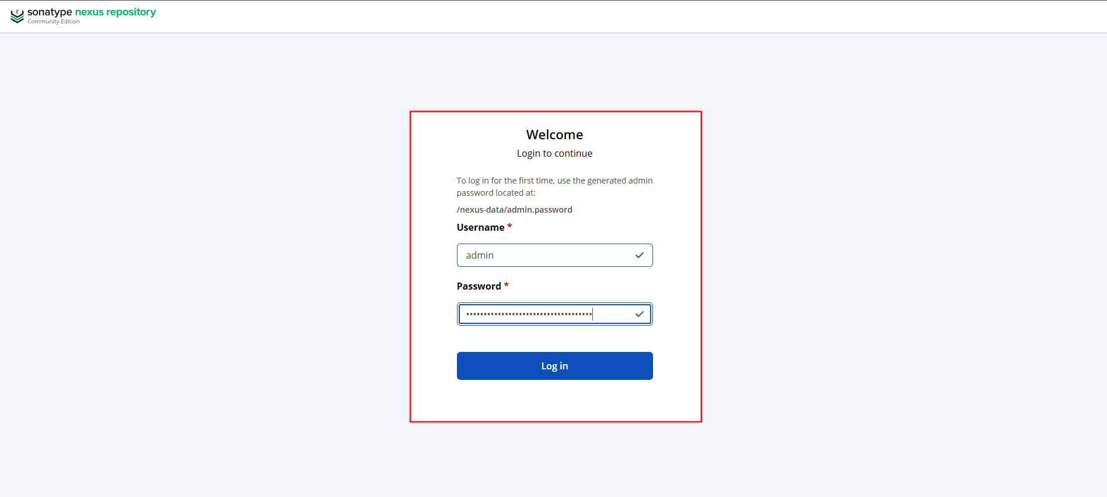
Explanation
Nexus stores:
- Maven artifacts
- JAR files
- Versioned builds
Validation
Login successful
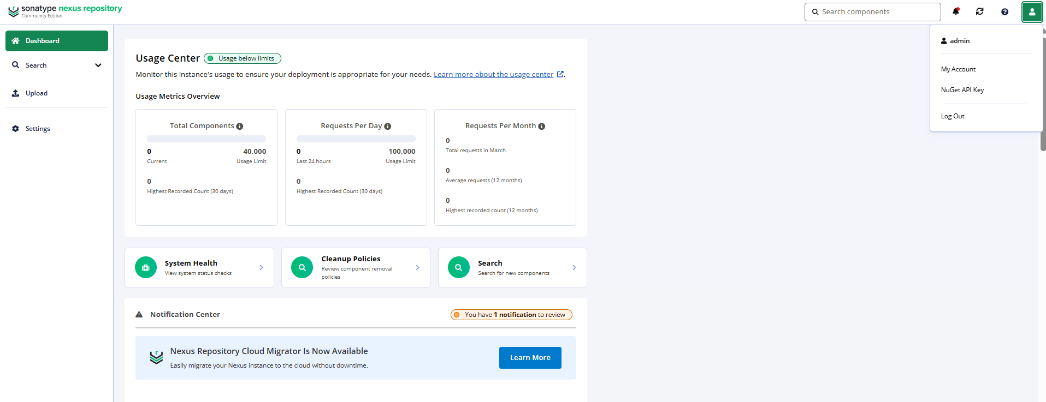
Install plugin: nexus artifact uploader
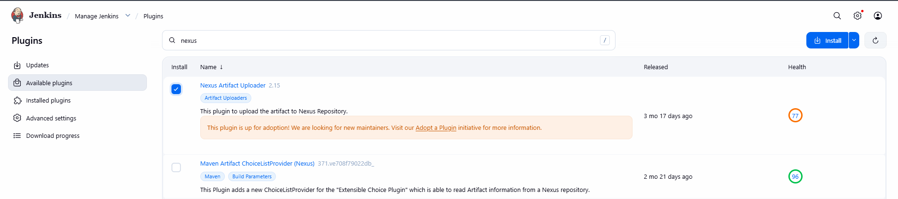

STEP 2.3 — Create Application Repository (hiring-app)
Project Structure
Create this structure:
hiring-app/
├── pom.xml
├── Dockerfile
├── Jenkinsfile
└── src/main/java/com/example/HiringApp.java

- Create Java Application
📄 src/main/java/com/example/HiringApp.java
package com.example;
public class HiringApp {
public static void main(String[] args) {
System.out.println("Hiring App Build Successful!");
}
}
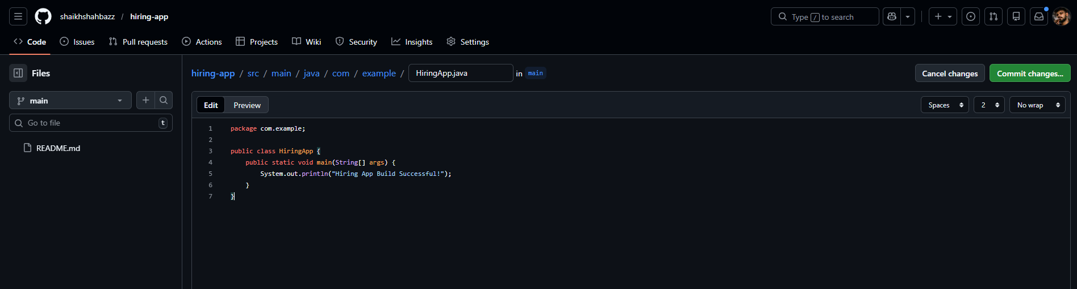
- Create pom.xml
This defines:
- Java 17
- Artifact name
- Nexus deployment location
📄 pom.xml
<project xmlns="http://maven.apache.org/POM/4.0.0"
xmlns:xsi="http://www.w3.org/2001/XMLSchema-instance"
xsi:schemaLocation="http://maven.apache.org/POM/4.0.0
http://maven.apache.org/xsd/maven-4.0.0.xsd">
<modelVersion>4.0.0</modelVersion>
<groupId>com.example</groupId>
<artifactId>hiring-app</artifactId>
<version>1.0.0</version>
<packaging>jar</packaging>
<name>hiring-app</name>
<properties>
<maven.compiler.source>17</maven.compiler.source>
<maven.compiler.target>17</maven.compiler.target>
</properties>
<distributionManagement>
<repository>
<id>nexus-releases</id>
<url>http://54.80.196.176:8081/repository/maven-releases/</url>
</repository>
</distributionManagement>
</project>
⚠️ Replace YOUR_NEXUS_IP with your Nexus EC2 public IP.
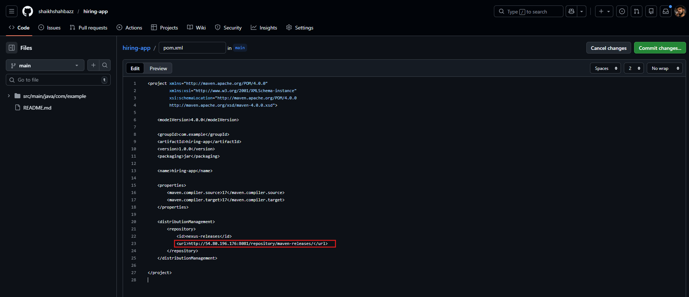
- Create Dockerfile

Dockerfile
FROM eclipse-temurin:17-jdk
WORKDIR /app
COPY target/hiring-app-1.0.0.jar hiring-app.jar
ENTRYPOINT ["java","-jar","hiring-app.jar"]
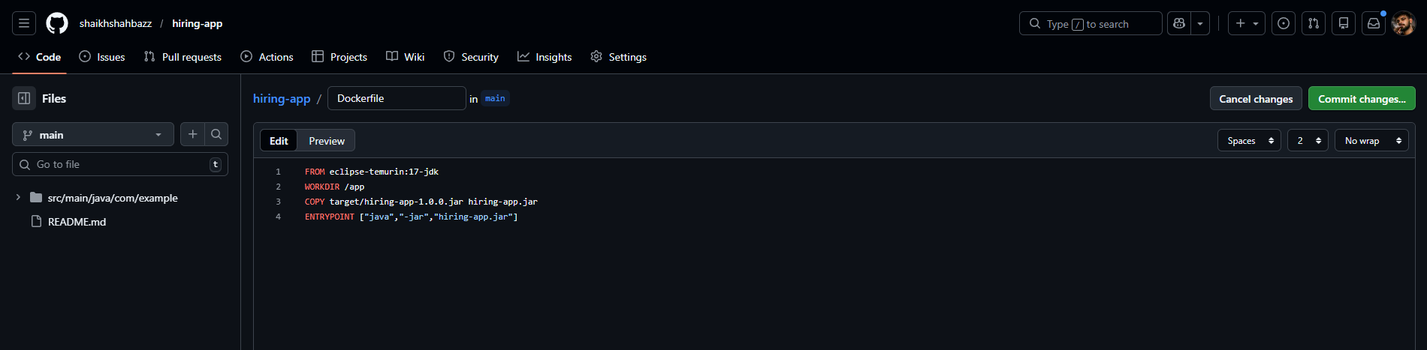
- Create Jenkinsfile (CI Pipeline)

Jenkinsfile
pipeline {
agent any
tools {
maven 'Maven'
}
environment {
SONAR_SERVER = 'SonarServer'
}
stages {
stage('Checkout') {
steps {
git 'https://github.com/shaikhshahbazz/hiring-app.git'
}
}
stage('Build') {
steps {
sh 'mvn clean package'
}
}
stage('Sonar Scan') {
steps {
withSonarQubeEnv('SonarServer') {
sh 'mvn sonar:sonar'
}
}
}
stage('Quality Gate') {
steps {
waitForQualityGate abortPipeline: true
}
}
stage('Upload to Nexus') {
steps {
sh 'mvn deploy'
}
}
}
}
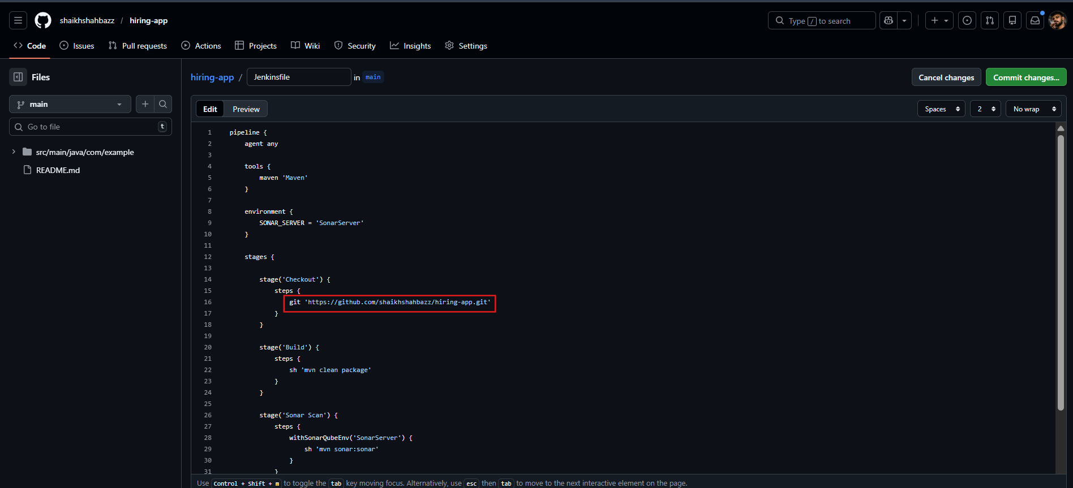
STEP 2.4 — Create Jenkins CI Job
Jenkins → New Item → Pipeline
Name: ci-jenkins-job
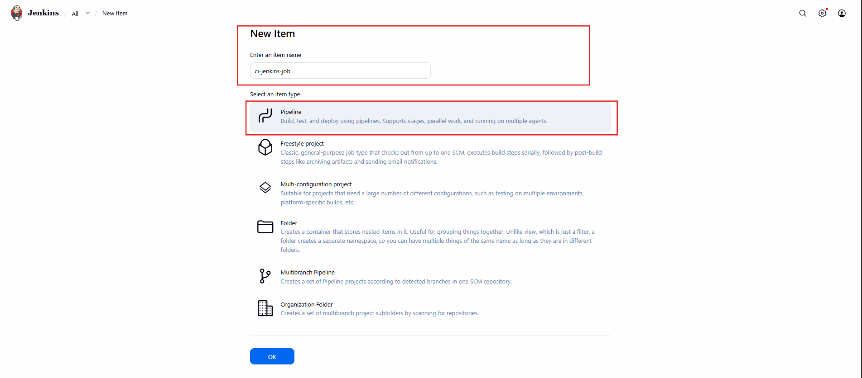
Choose:
Pipeline from SCM
Git → hiring-app repo URL
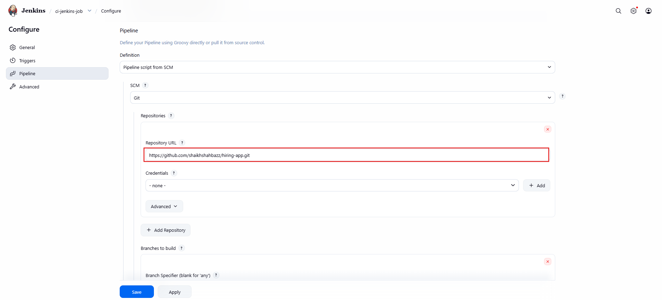
Click:
Build Now
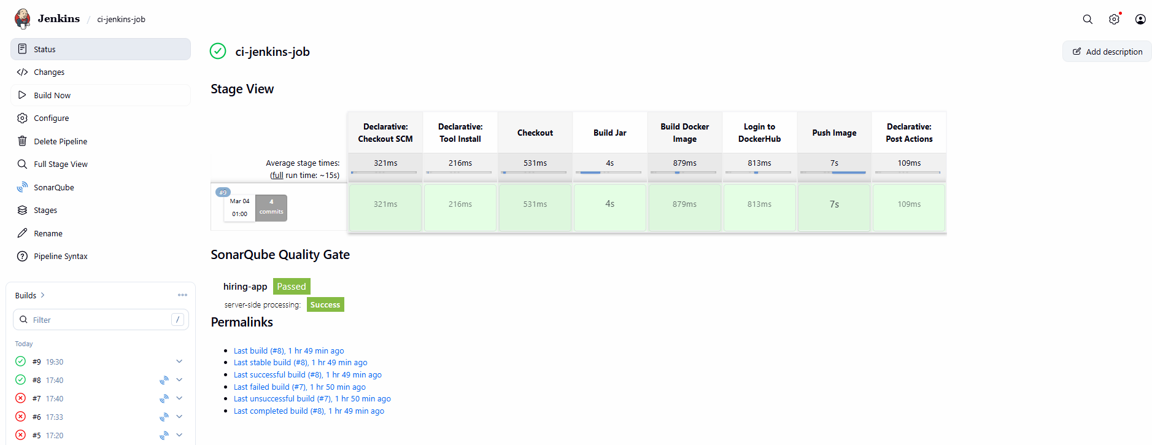
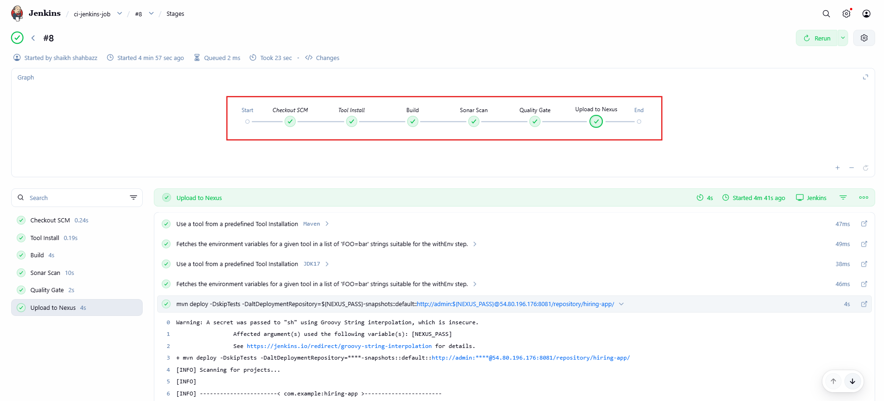
Validation Checklist
✔ Build success
✔ Sonar project updated
✔ Quality Gate passed
✔ Artifact available in Nexus
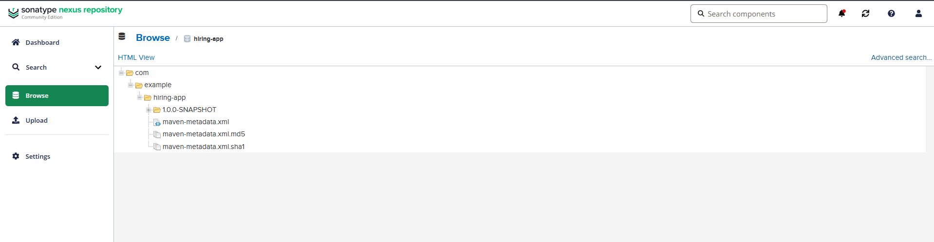

TASK 3 — Create Jenkins job to create docker image and build image.
Step 1: Make Sure Docker is Installed on Jenkins Server
Run on Jenkins server:
docker --version
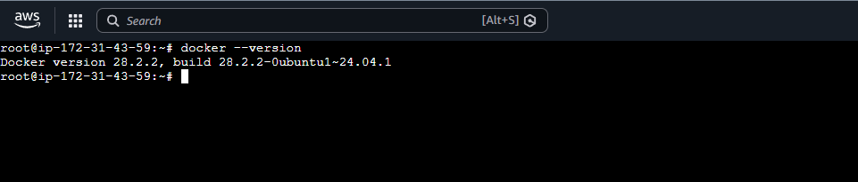
Step 2: Add Dockerfile in Your Project
📄 Dockerfile
FROM eclipse-temurin:17-jre-jammy

WORKDIR /app

COPY target/hiring-app-1.0.0-SNAPSHOT.jar app.jar

EXPOSE 8080

ENTRYPOINT ["java","-jar","app.jar"]
Commit & push this file.
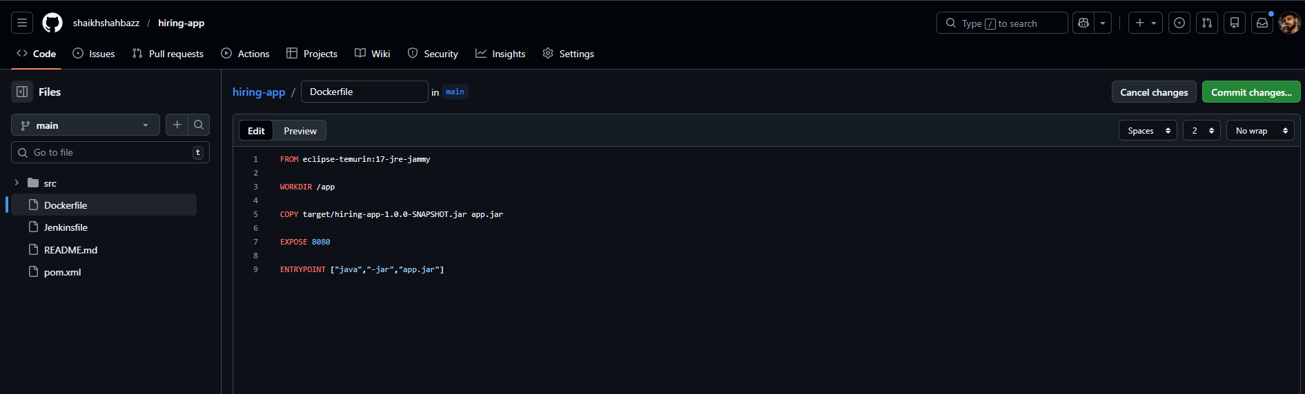
Step 3: Create New Jenkins Pipeline Job
Name:
docker-build-job
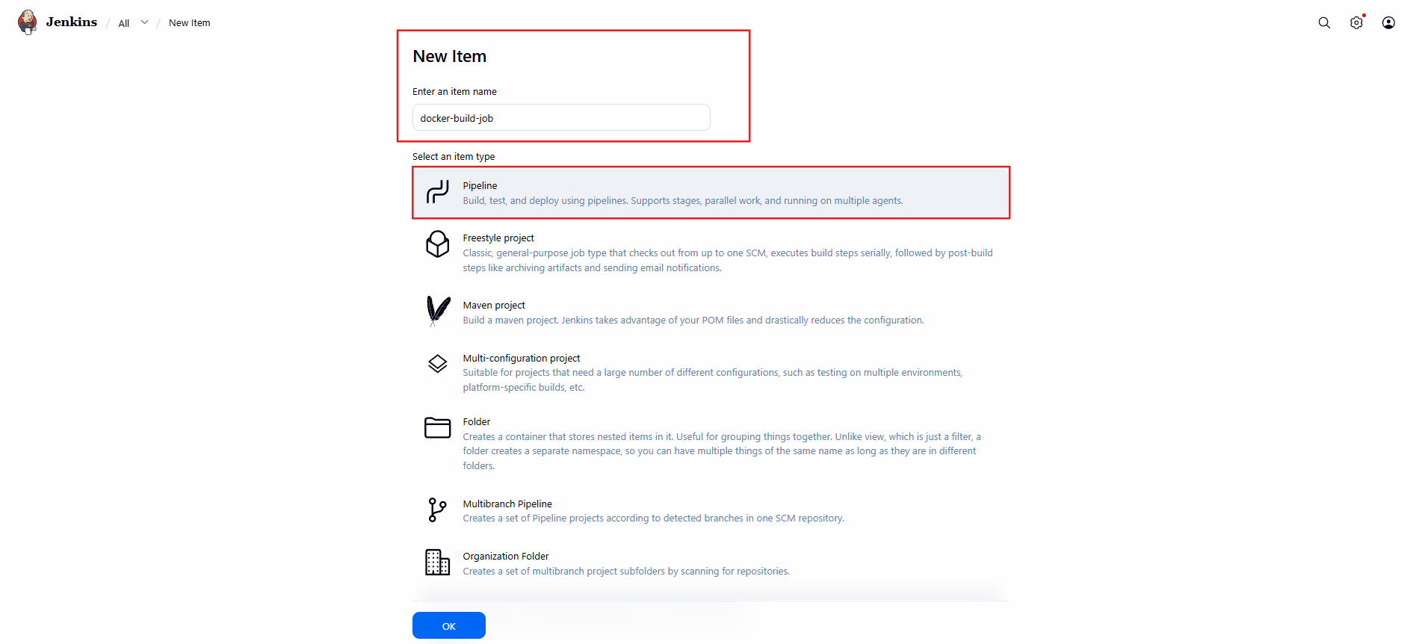
Use Pipeline → From SCM → Same Git repo.
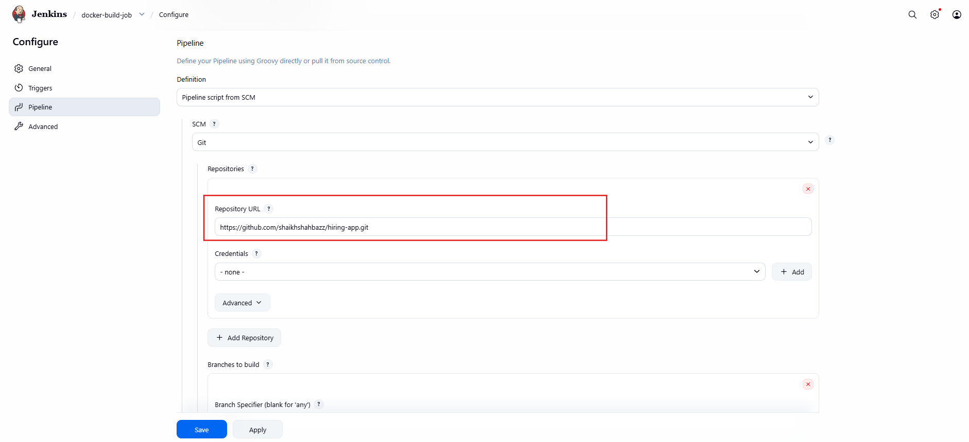
Step 4: Jenkinsfile for Docker Build
Add this Jenkinsfile
pipeline {
agent any

tools {
maven 'Maven'
jdk 'JDK17'
}

environment {
IMAGE_NAME = "shahbazz16/hiring-app"
IMAGE_TAG = "1.0.0"
}

stages {

stage('Checkout') {
steps {
checkout scm
}
}

stage('Build Jar') {
steps {
sh 'mvn clean package -DskipTests'
}
}

stage('Build Docker Image') {
steps {
sh """
docker build -t $IMAGE_NAME:$IMAGE_TAG .
"""
}
}

stage('Login to DockerHub') {
steps {
withCredentials([usernamePassword(
credentialsId: 'dockerhub-creds',
usernameVariable: 'DOCKER_USER',
passwordVariable: 'DOCKER_PASS'
)]) {
sh """
echo $DOCKER_PASS | docker login -u $DOCKER_USER --password-stdin
"""
}
}
}

stage('Push Image') {
steps {
sh """
docker push $IMAGE_NAME:$IMAGE_TAG
"""
}
}
}

post {
success {
echo 'Docker Image Pushed Successfully!'
}
failure {
echo 'Pipeline Failed!'
}
}
} 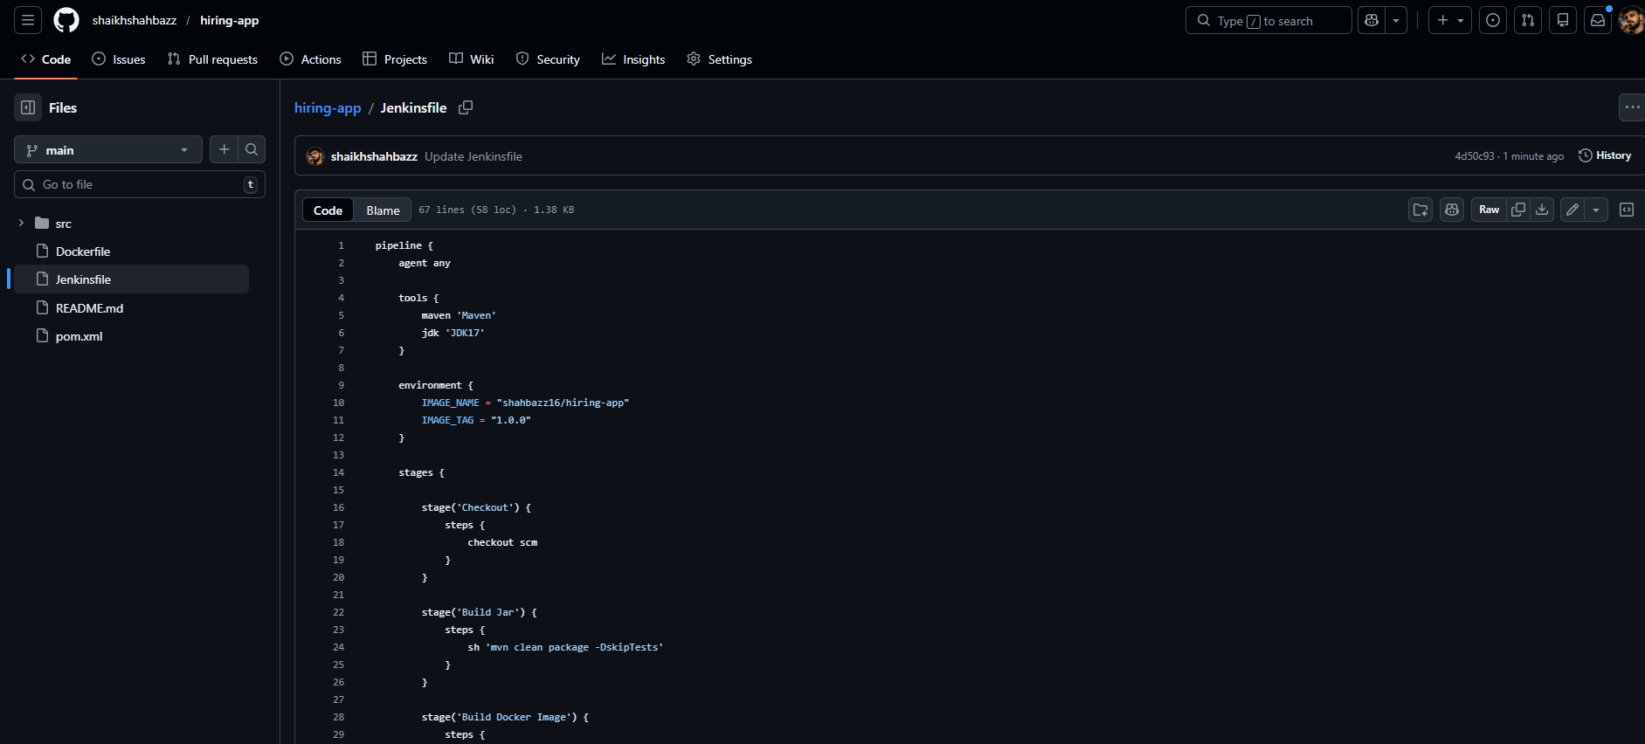
Step 5: Run Job
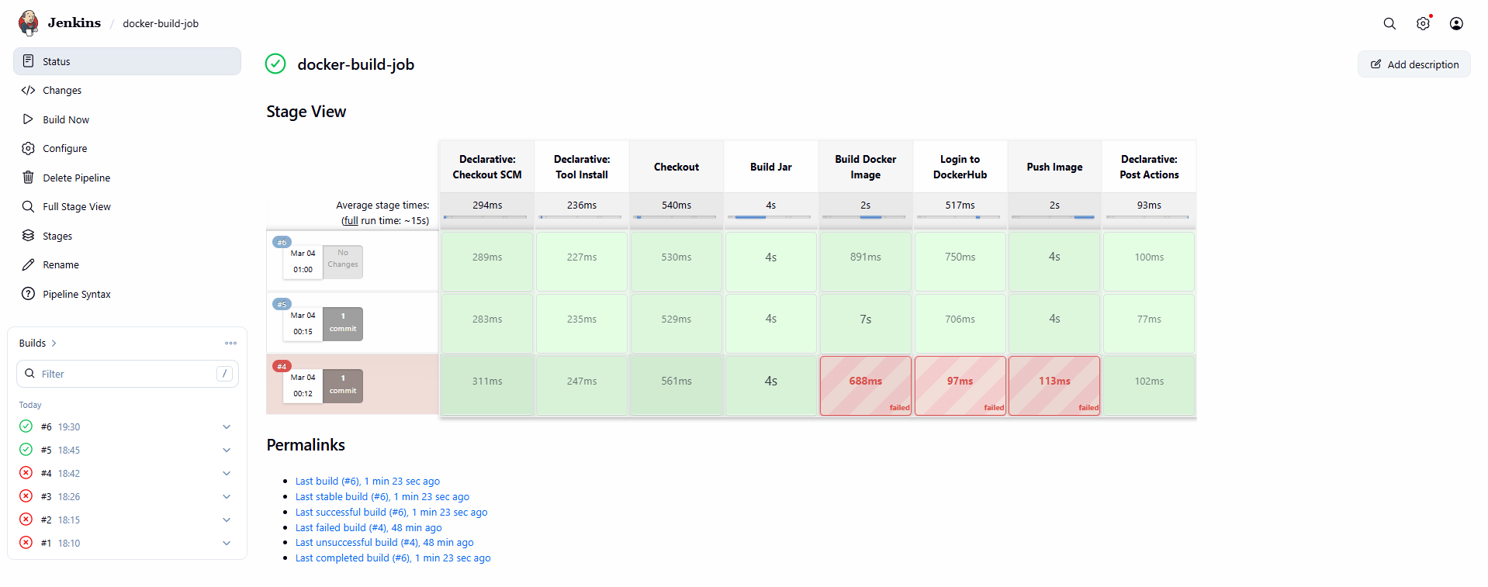
After running, check:
docker images
You should see:
shahbazz16/hiring-app 1.0.0
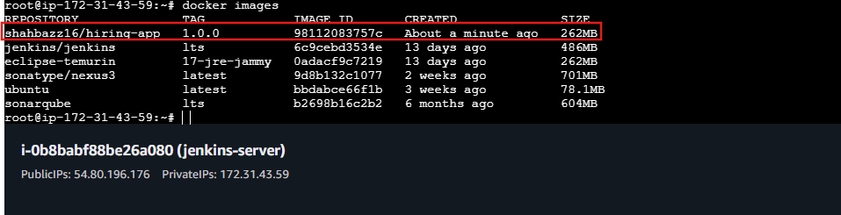

🎯 Final CI Flow So Far
Job 1:
- Build
- Sonar
- Upload JAR to Nexus
Job 2:
- Build JAR
- Build Docker image
- Push Docker image
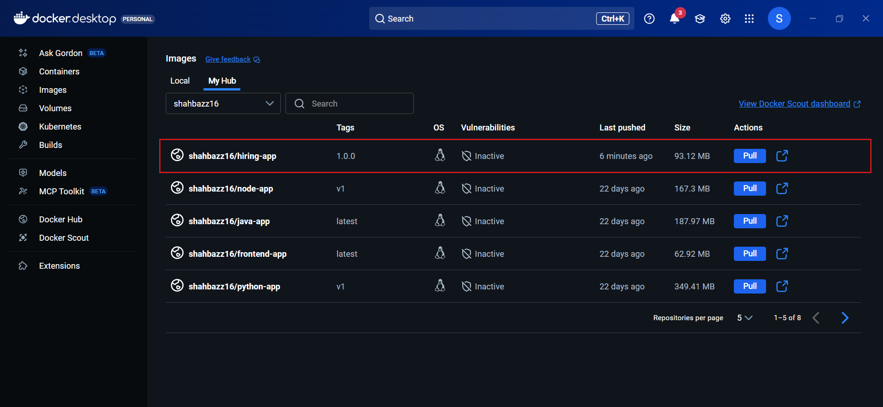

TASK 4 — Create ArgoCD Job to Deploy on EKS Cluster

Overall Flow
DockerHub → ArgoCD → EKS Cluster
ArgoCD will:
- Read Kubernetes YAML from GitHub
- Deploy into EKS
- Auto-sync when image updates

STEP 1 — Create Kubernetes Deployment YAML
Inside your GitHub repo create folder:
k8s/
Create file:
deployment.yaml

📄 deployment.yaml
apiVersion: apps/v1
kind: Deployment
metadata:
name: hiring-app
spec:
replicas: 2
selector:
matchLabels:
app: hiring-app
template:
metadata:
labels:
app: hiring-app
spec:
containers:
- name: hiring-app
image: shahbazz16/hiring-app:1.0.0
ports:
- containerPort: 8080
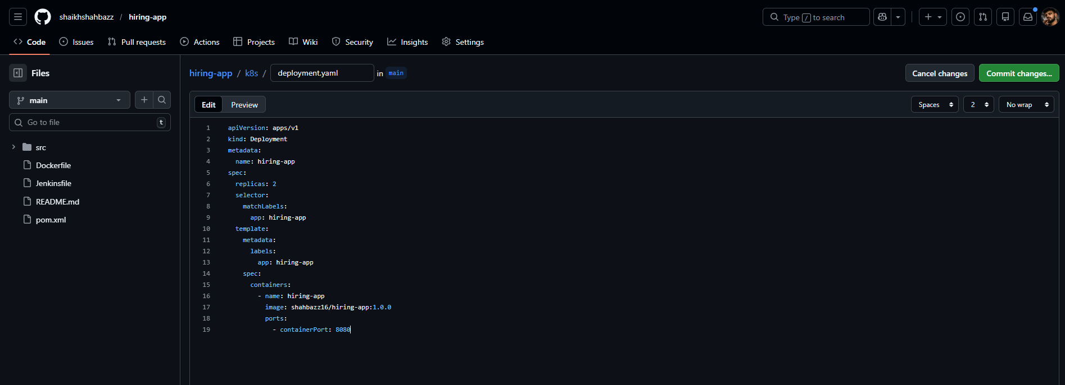
📄 service.yaml
apiVersion: v1
kind: Service
metadata:
name: hiring-app-service
spec:
type: LoadBalancer
selector:
app: hiring-app
ports:
- port: 80
targetPort: 8080
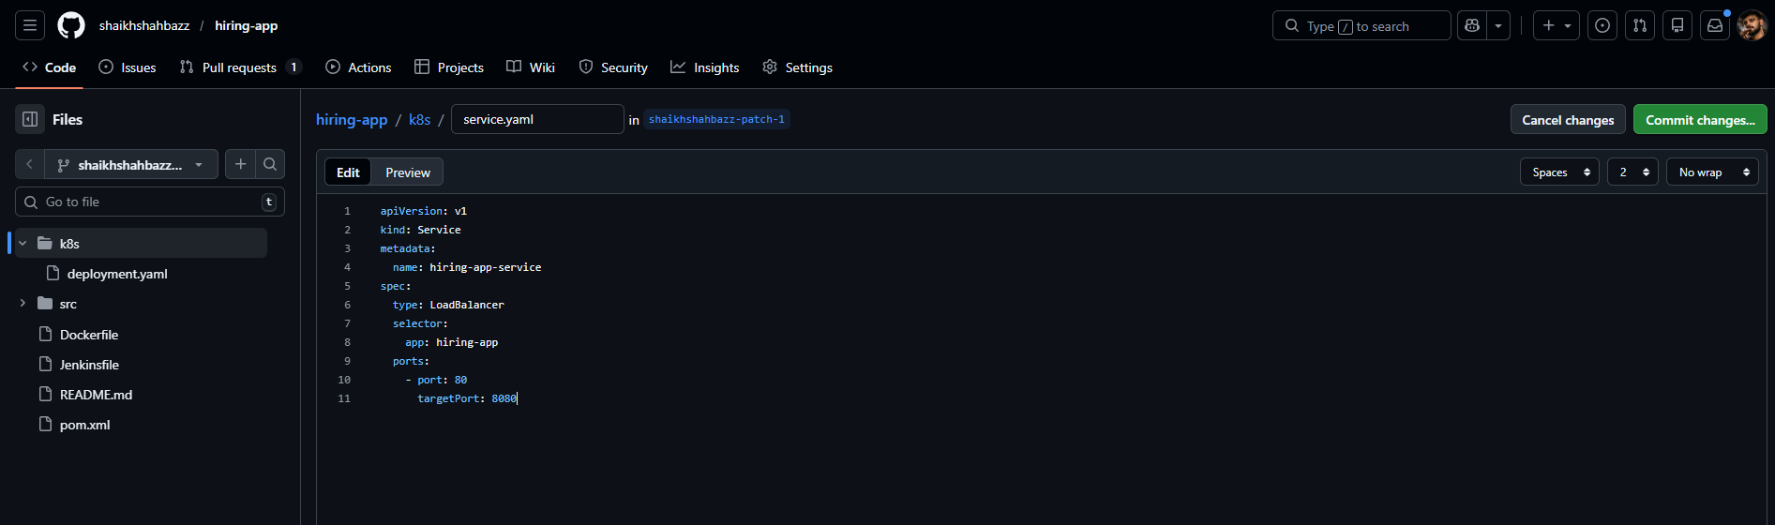
STEP 2 — Login to ArgoCD
Open:
http://<argocd-server-ip>
Login with admin credentials.
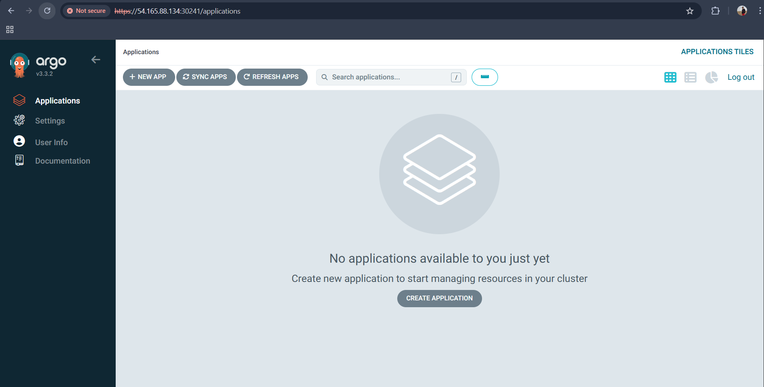
STEP 4 — Create New Application in ArgoCD
Click → NEW APP
Fill like this:
Application Name: hiring-app

Project: default

Sync Policy: ✔ Automatic

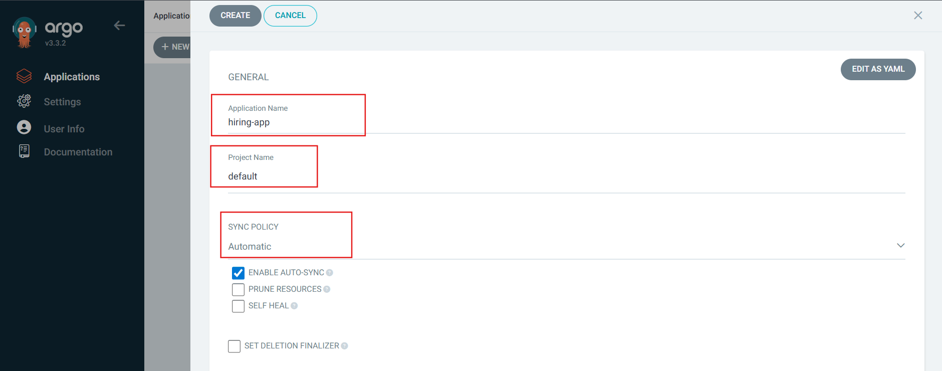
SOURCE
Repository URL: https://github.com/shaikhshahbazz/hiring-app.git

Revision: shaikhshahbazz-patch-1
Path: k8s

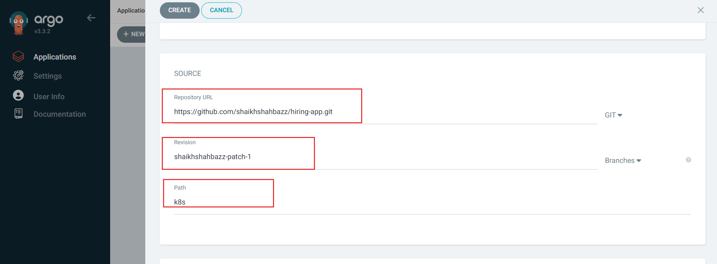
DESTINATION
Cluster: https://kubernetes.default.svc

Namespace: default
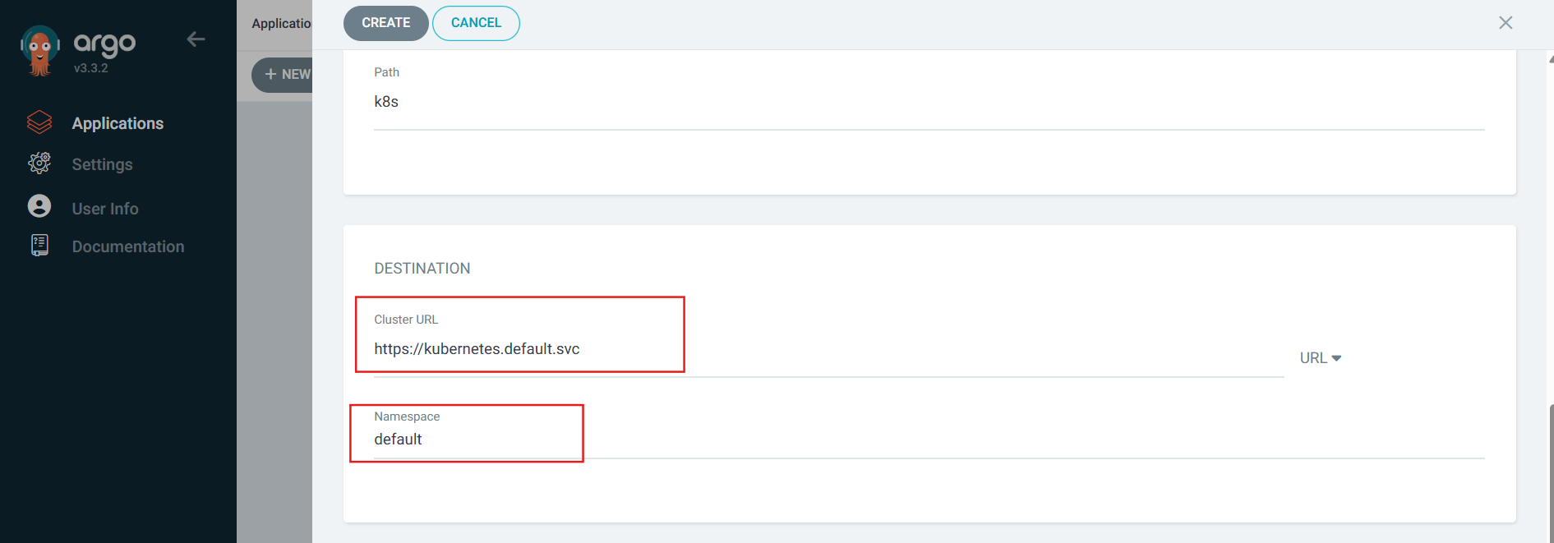

Click → CREATE
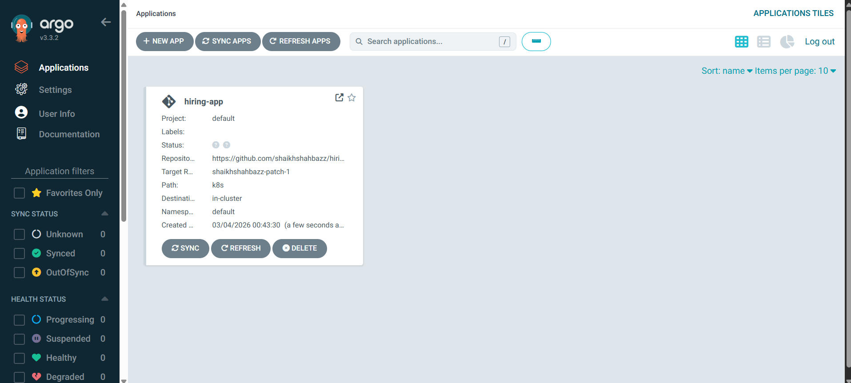
STEP 5 — Sync
Click → SYNC
After few seconds it will show:
🟢Healthy
🟢 Synced
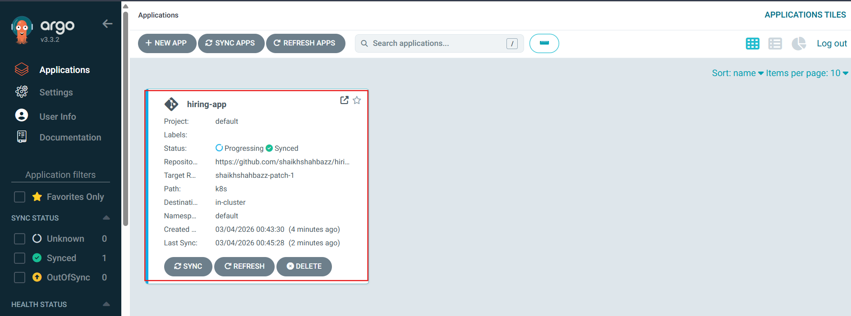
✅ STEP 6 — Verify on EKS
On your EKS master:
kubectl get pods
kubectl get svc
You should see:
hiring-app
hiring-app-service
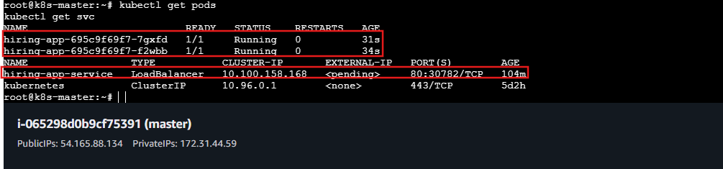

🎯 Now Your Flow Is:
Jenkins → DockerHub → ArgoCD → EKS → Live App

